AEM INSTALLATION

STEP 1: Downloading AEM Jar File

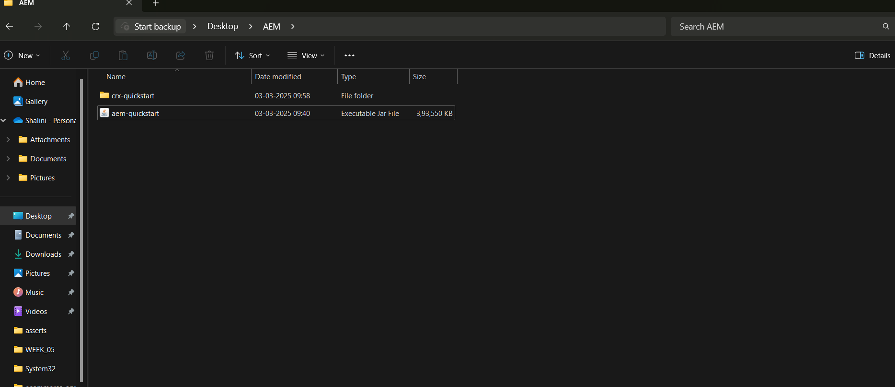

STEP 2: JDK 11 Installation and Maven installation

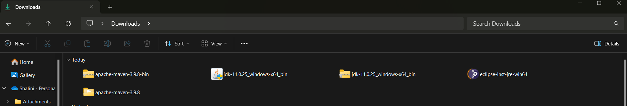

STEP 3: AEM server page

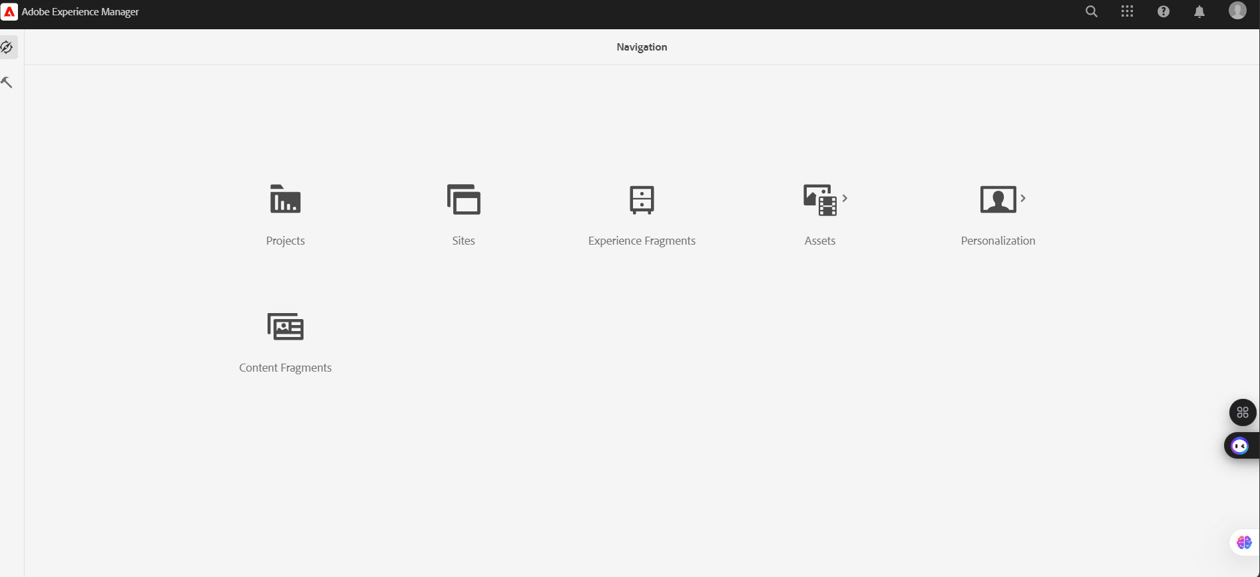

STEP 4: Connecting Maven

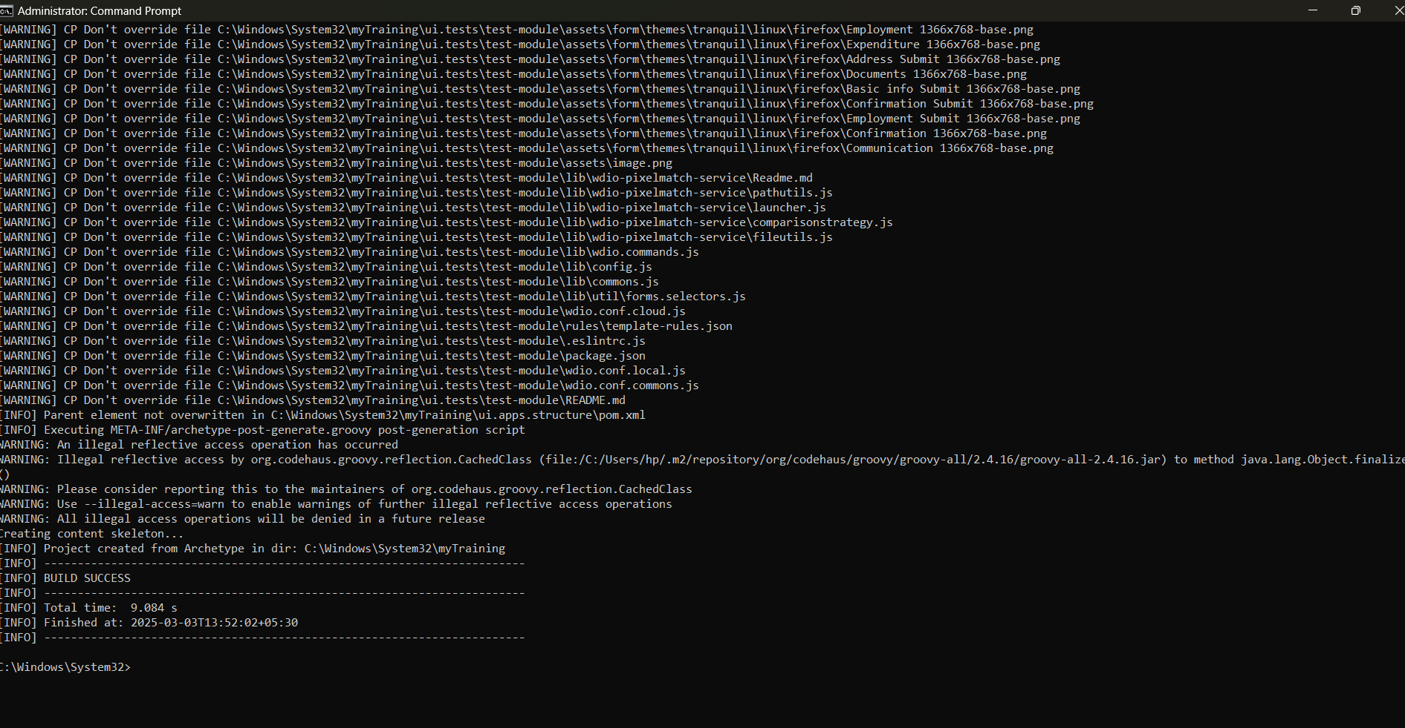

STEP 5: VS code

